The City of Arcata
Electric Vehicle Charging Station

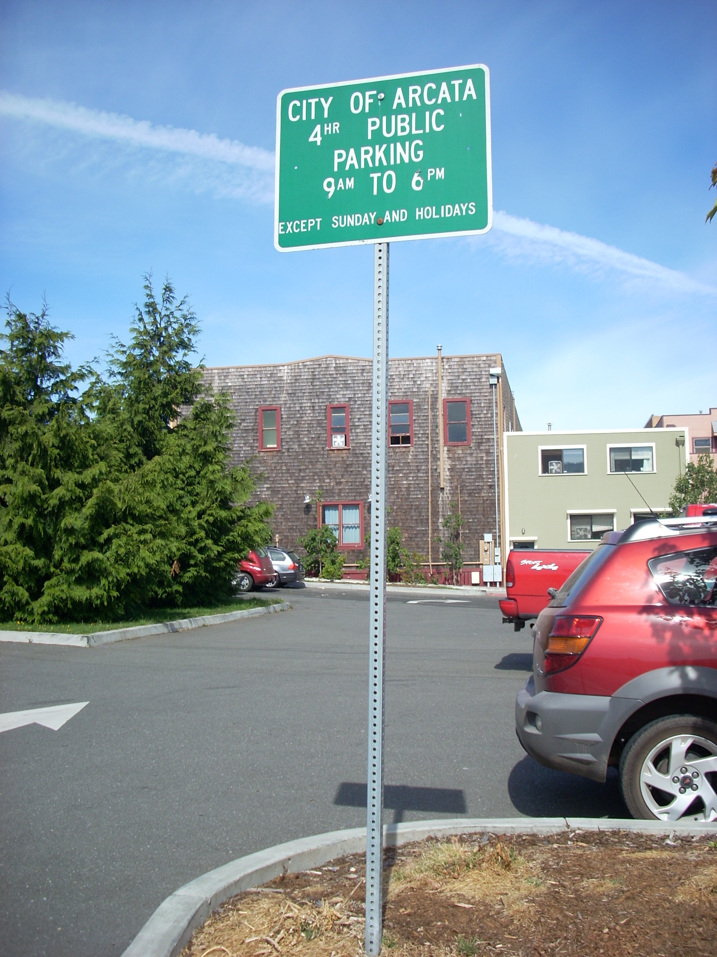
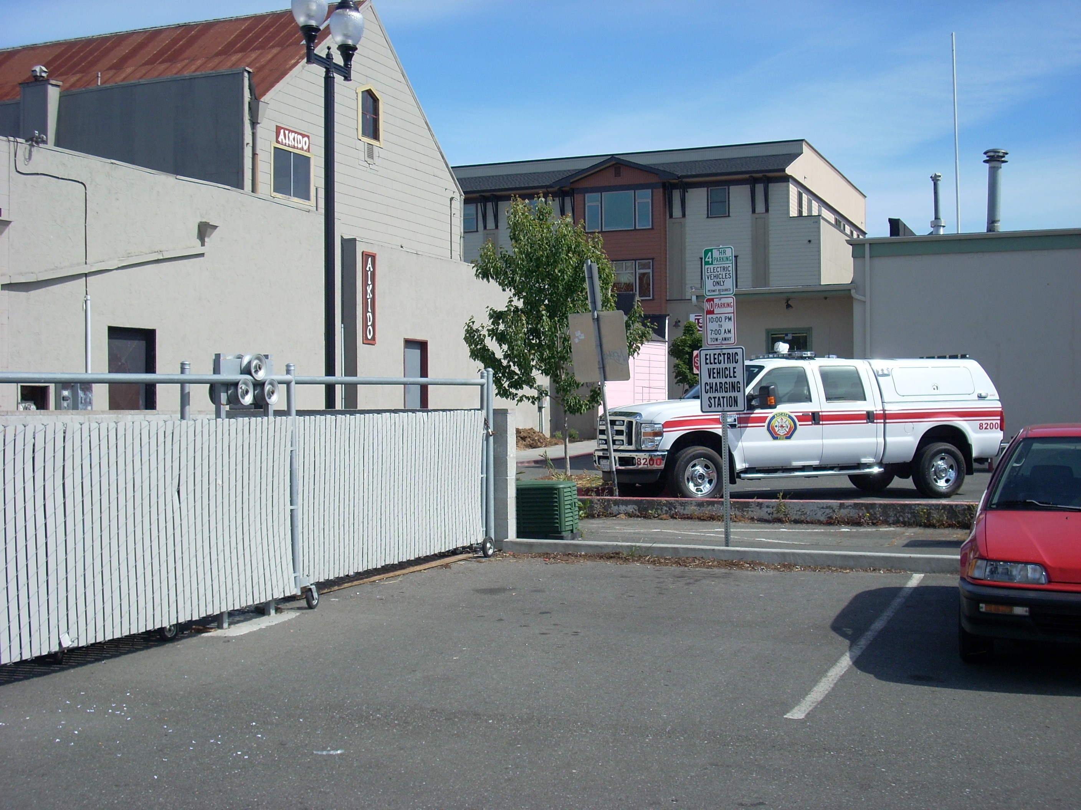
The City of Arcata has recently installed a new Electric Vehicle Charging Station that will be free and open to the public. The station is located in the parking lot on the corner of 9th and F streets in downtown Arcata California. The parking space is available for electric vehicles from 7 am to 10 pm. No cord is provided for charging, so please bring your own cord. The parking spot is located in the back of the lot, close to the alley, and is clearly marked with signage. The charger itself is located on the gray cinderblock next to the spot, and is also marked with signage. The charger is locked, and the combo is available at City Hall upon receipt of a liability waiver and charging station protocol, available at the Environmental Services Desk (for more information, see “How to Use the Charger”, below.)

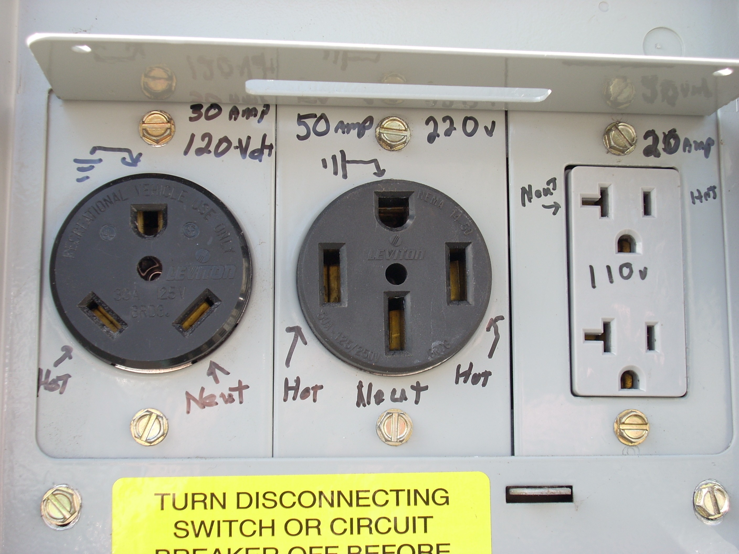
The charger is equipped with two 220 volt plug-in sockets and two 110 V plug in sockets, each at a different amperage. The close up picture at left shows the panel and sockets, each labeled with voltage and amperage.

For more information, call the City of Arcata Environmental Services Department at (707) 822-8184.
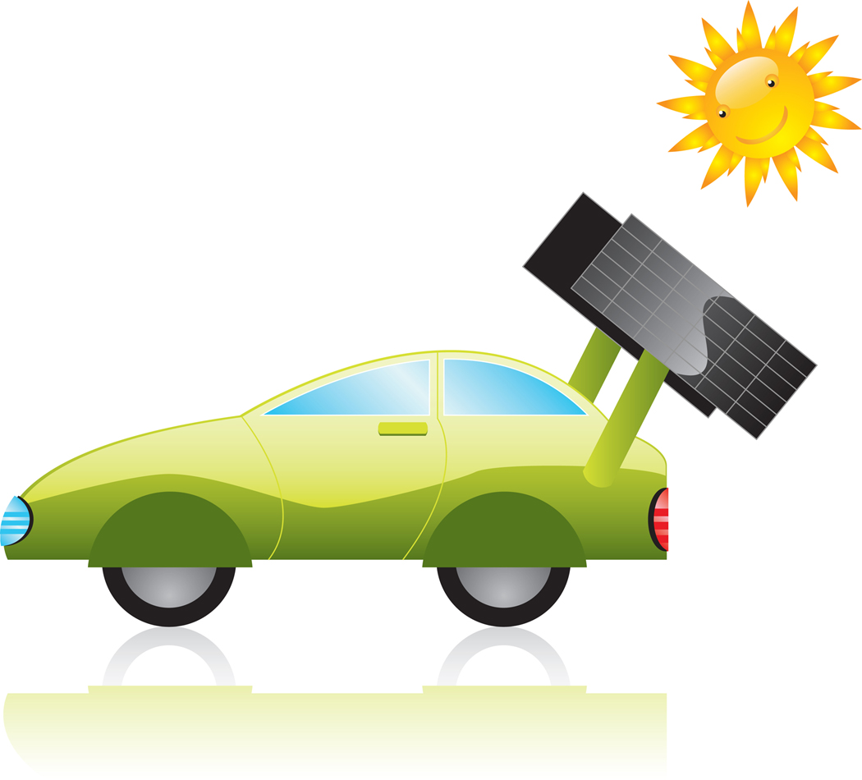
Welcome to the
City of Arcata
Electric Vehicle Charging Station

The City maintains this station so electric vehicles can recharge at no cost. This is just one of many efforts the City of Arcata has undertaken to reduce greenhouse gas emissions in our community and support sustainable transportation.
How to use this station:
- Obtain the combo for the lock by visiting the Environmental Services Department in City Hall (corner of 7th and F).
- If City Hall is closed, you may obtain a combo by contacting the Humboldt Electric Vehicle Association at 822-6972 or 826-9901.
- While charging, please be courteous and display a charging placard, available at City Hall, clearly on your windshield.
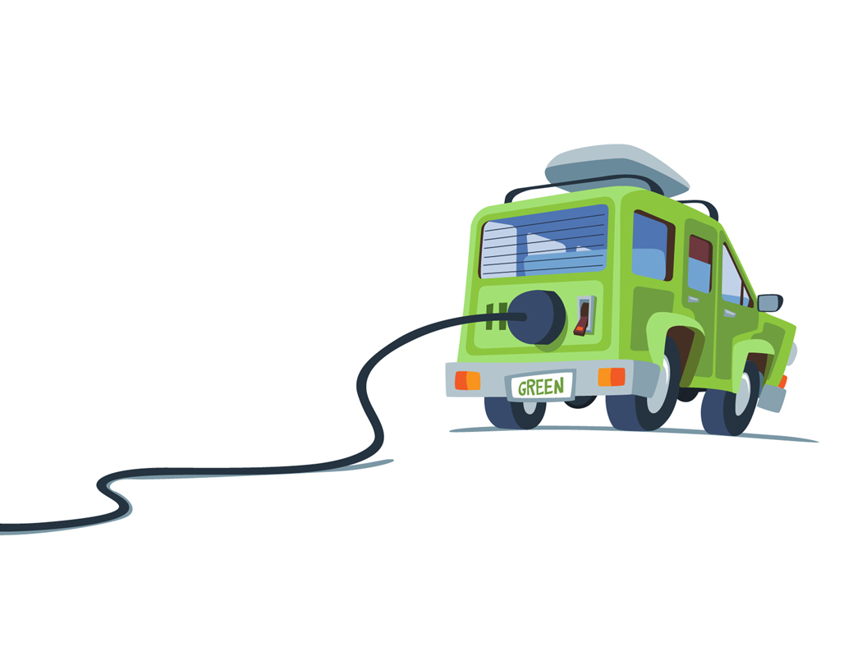
- If you will be leaving your car here for an extended period of time (no more than four hours), please be conscious of other users and leave access to your charging port.
- Don’t forget to lock the port when you are finished, and thanks for visiting the lovely City of Arcata!

Please report any malfunctions to the City of Arcata
Department of Public Works at 826-5957.

